Development Section

# Ideas for the project

The idea of making a website has always been in my head. I find them really mysterious, but interesting at the same time, which it makes it the perfect topic to do an EPQ on it. When deciding about the type of website that I was going to build, I thought about different ideas and topics that would be both easy and relatable to me as a student, such as:

* A website with simple games created by me. This idea was scrapped due to how time consuming it could have been.
* A website/online-shop that advertised on-demand products that are being sold in amazon or eBay. I decided not to proceed with this idea as I don’t know how to manipulate API’s at this level.
* A website with revision material for GCSE students. I went for this choice as it is something that I know a lot about and it’s highly relatable to me.

# Planning of the website

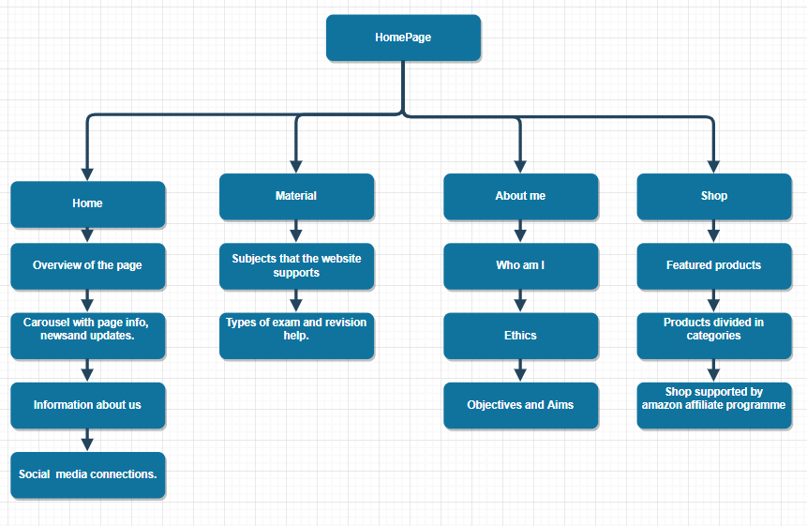At the beginning of the project I had to do a plan of how I will structure the website. My research indicated that by doing this not only I will save time later on but it will be easier to code as I already have a general idea of how the website will look like.

I started by creating a flowchart of the homepage of the website, which is the page that the user will first see when entering my website. In this flowchart I specified not only what I was going to put in the homepage, but also the topics that I was going to put in the other pages (about-us, materials etc.) as well. Later on in the project I decided that this flowchart wasn’t suitable for the project anymore as I was not going to do the shop due to timing issues. This led me to create another Homepage flowchart.

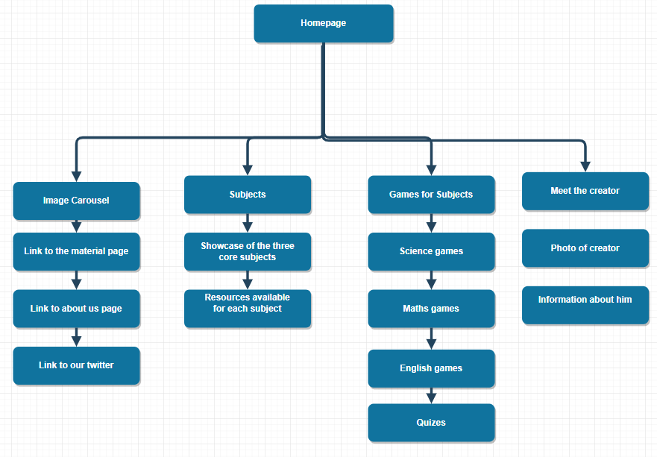The final flowchart for the homepage included all the specific topics that are covered in the homepage only. In this flowchart I portrayed all the different sections on the page and its respective content within them.

After doing this flowchart, the design of the website seemed clearer that before which help me a lot when coding the website, as it gave me a clear structure to follow.

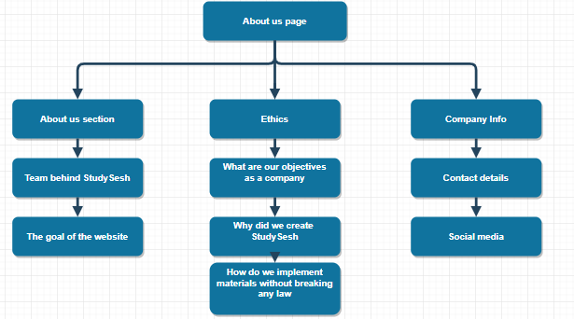

Later on in the project after I created the homepage, I decided to start designing the about us page. For this task I created a flowchart for the structure of the page. This initial flowchart was the best I came up with as it explains thoroughly the main components of the page in each section.

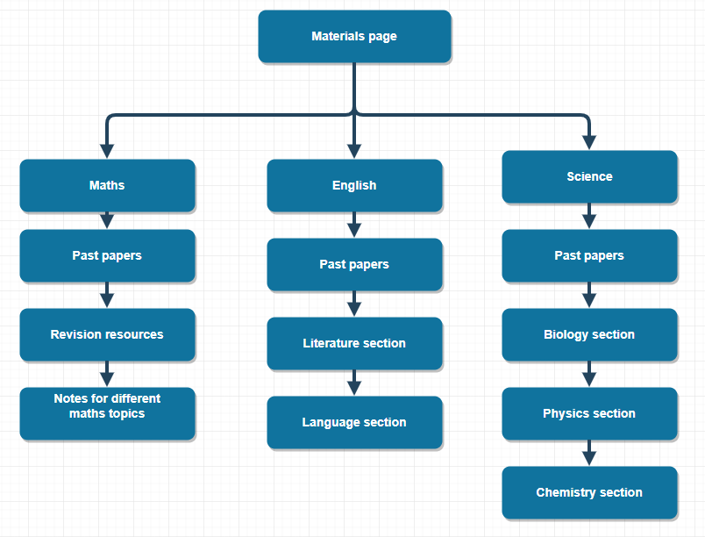

After I designed and built the about us page, I proceeded to create a flowchart for the material page. On this flowchart I tried to structure how the page it’s going to be linked to its subpages (Maths, English and science) and also the type of content that those subpages are going to contain. The finished flowchart was very detailed and very good explained so I decided to build the Materials page around it.

# Choice of Programming Languages

One of the most integral aspects of web development is web programming that is achieved with the help of programming languages. Web development languages are the platforms through which instructions are communicated to a machine and actions are pursued. The main programming languages that I chose to create my program are:

* HTML - this is the scripting language of the web used to define structure of a website.
* CSS - this is the design and layout language used on the web to turn your website from an empty frame into something pretty and well laid out.
* JavaScript/ jQuery - this adds animations, or improved user experience elements to your website. Sliders, menu navigation, animations, etc will require JavaScript. You can also use jQuery which is a library built on top of JavaScript to make a few things easier.
* Bootstrap - is a framework to help you design websites faster and easier. It includes HTML and CSS based design templates for buttons, navigation, image carousels, etc. It also gives you support for JavaScript plugins.

# Choice of the Text Editor

Choosing a good text editor makes a big difference on many parts of the project, such as: efficiency when writing code, compatibility of the program and make programming easier by autocompleting repeating code. This are some of the text editors that are famous for their quality and performance:

* Sublime-Text: Its interface is friendly, so it is easy to use, it has a very good number of keyboard shortcuts that allows me to quickly access any program complement or perform any operation. This helps programmers to be more efficient when writing code.
* Atom: atom is a free to use text editor that’s very beginner friendly. It has a lot of features that help users to write code such as integrated Developer Tools and Ui that’s easy to customize. This text editor is also well connected to GitHub, the platform that I use in order to organise myself when doing computer science project.

For this project I chose to use Atom as my preferred text editor as it proves to be very useful and reliable when writing code, but also very easy to use.

# Ideas for the name of the Website

When choosing a website name, a business has to be very careful by what the name represents, as they won’t be able to change it in the future. The name of the website is also required to be simple and good looking, so when a user sees it in another website, he/she will be incited to click on the link.

As the website is based on GCSE revision and is focused to young audiences, it means that the name of the website must contain some words that are familiar to teens. I chose this approach as younger audiences are usually more attracted to things that they find relatable.

Some of the names that I came up with were:

* MasterGCSE: I considered this name inappropriate for the website as it was both too long and not very relatable to the target audience
* RevSite: It was a name combined from a mixture of ‘Revision’ and ‘Site’.
* StudySesh: It’s a combination of the words ‘Study’ and ‘Sesh’ (sesh is an abbreviation of the word session). This name is very concise and uses language that is common between teenagers, which makes it more relatable.

# Choice of the website’s base colours

As mentioned in my ‘Website project brief’ under the exemplar websites topics, the main colours that I was aiming to use in this website would be predominantly whiter colours, as they are associated with a modern look. I also added other colours such as blue and black, so the website wouldn’t look too simple. A small mix of colours also adds a sense of variety that users can associate with. When combining them, I also had to make sure that they weren’t obstructing colour-blind users from navigating the page, as the user experience is of great importance for the success of a website.

# Choice for the main font of the website.

Choosing the main font for your website is usually one of the most important choices a web-developer can make. Text in a website should look approachable to the user and somehow look familiar to him, so that he may be inclined to read it. Moreover, the size of the font also depends on the type of heading of the text. For example, a main heading can’t have the same size as the paragraph following it, it just doesn’t look right for the user. Therefore, when selecting the fonts I need to decide the size of the fonts to use for the headings and the paragraphs.

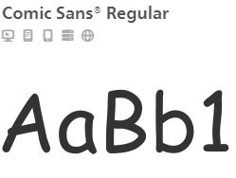Font discussion:

At the beginning of the project I decided to use the ‘comic-sans’ font for all the text because it was a font that is very familiar to my target audience. I also chose this font because it was very easy to implement in the website.

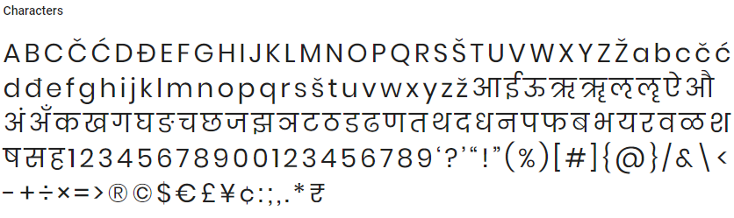

Later on in the project I decided to change the main font to ‘poppins sans-serif’. I decided to change to this font because I though that the ‘comic sans’ font looked to childish in the website and didn’t completely suit my target audience.

Size discussion:

For the paragraphs of text I decided to use the paragraph section in HTML (which looks like this: <p></p>). This code allows me to resize a specific part of text. I used this across all of the pages when I tried to add text to the website in order to maintain a consistent size for the website. 

The code above shows an example of how the paragraph section in HTML is used. In this exaple the text in white will be displayed in the webite at a small font size, which is the optimal solution. On the other hand, for headlines I used the Headline section offered again by HTML (looks like this <h1></h1>). This code increases the size of the text and the level of boldness depending on the number used inside the brackets (numbers between 1 to 8 can be used).

The line of code above will make the white text be increase in both size and boldness. This will make the text look more like a headline to the user, which is the intended solution.

# Content requirements

The content is the heart of a website. For the page to be successful it needs content that is up to standards and attracts the audience that you are targeting. Through research I concluded that the content of my website must follow these rules:

* 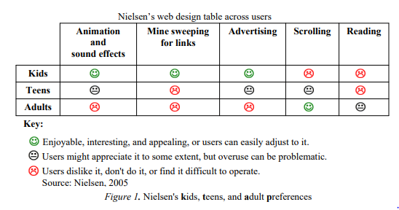The content has to appeal to teenagers.
* The website should have a low amount of text for the user to read.
* It should contain animations and special effects.
* Advertising is allowed but should be kept to a minimum.

By meeting these requirements, I’m adapting the website to the audience demands.

# Choice of images for the Homepage

When choosing images for the website I have to be very careful that I don’t make any copyright infringement, which basically means that I can’t use images that are copyrighted by other authors. Therefore I will have to create most of the images used in my website to avoid any copyright issues.

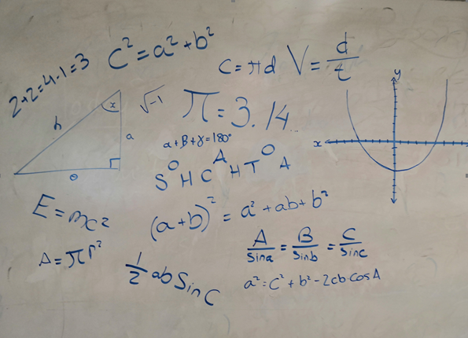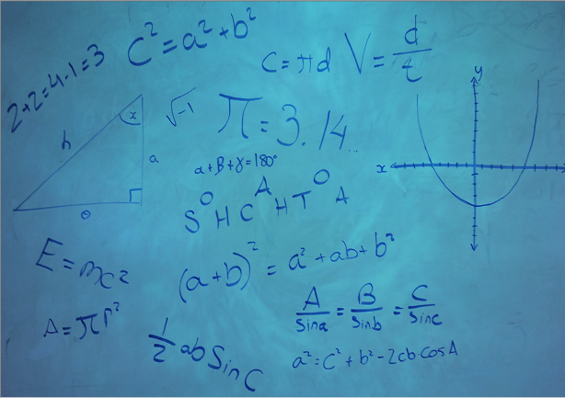The first image that the user can see when entering the website is the carousel image that has many equations and graphs in it. I designed this image in a classroom’ board by drawing random equations in it. I then took a photo of it (image in the right), and then proceeded to Photoshop it to make it look more attractive. The final result is the image to the left, where blue is the dominant colour, as blue is one of the main colours of the website.

When scrolling down in the homepage this image will show up under the ‘Meet the Creator’ Section, followed up by some information. I was sceptical at first in whether to put my image into the website or not. At the end I decided that adding my image will make the website more authentical, as it’s not a stock photo of a random person. I also used this image in the about us page under the same section.

# J:\Extended Project\Classes\Level 3 Extended Project D2\elanzavalenciano17\Extended-project\Extended-project-v.2-master\Website Files\img\english1.pngChoice of images for the Materials Page

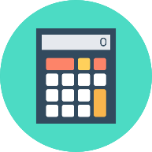Choosing images for this page was very difficult and challenging as I had to comply with copyright laws to the best of my ability. For this page I was searching for icons that represented the 3 different core subjects and that were colourful at the same time.

For this type of request I went to a stock-photos provider’s website in order to search for icon that didn’t have any copyright.

In there I found these three icons that were made by the same person that stated that its icons were copyright free. I thought they were perfect for my website as they were of different colours and also contained an item that is unique to its subject.

# Choice of images for the About us page

# Logo of the website

A logo is an important part of your company's brand, and makes a significant impact on a company's public perception. In fact, a logo is one of the most important branding investments a business can make. A logo can be described as the face of a company.

For this reason I dedicated a lot of time and effort to create a logo that is relatable to students and attracts their attention when looking at it.

For the design of the main logo I created a big letter S that had a bold letter S inside of it in order to symbolise that the two initials in the name of the website, StudySesh. After designing this in Photoshop I added the name of the website on its right because the S alone looked too simple and not very attractive. This way the user knows what the symbolisms of the big S tries to portray.